GPS tracker user manual
For Watches style and Hanging style
LOG IN : WWW.GPS1388.COM
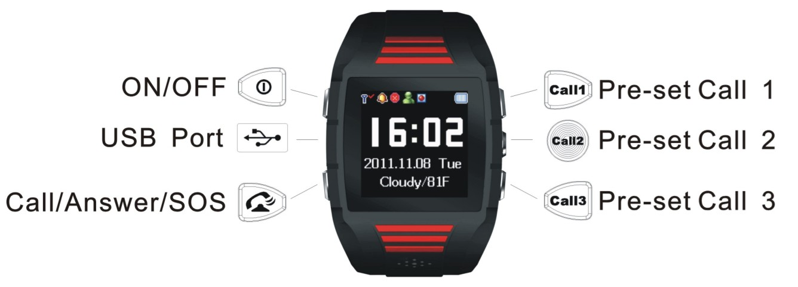
Display icon
GPS on, positioning.
GPS on, not yet position.
Management platform turn on. The device connecting the platform through GPRS network, the platform can send commands to the tracking device.
Device sending position information to the platform.
Tracking record turn on.
Quiet mode turn on.
Allows only incoming preset number
Closes the GPS localization pattern

- Key Definition
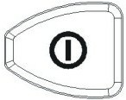 ON / OFF
 USB Port
 Call / Answer / SOS
 Pre-set Call 1
 Pre-set Call 2 guardian
 Pre-set Call 3
- Specification
GPS location accuracy 15 M
GSM Network accuracy 200 M
GPS Band 1575 MHz
GSM Band 850/900/1800/1900 MHz
Display Size 1.44 TFT
Standby consumption 1 to 3 mA
GPS connecting 70 mA
Standby time 7 days
Continuous monitoring 8 - 10 hours
Battery 600 - 750 mAh Hi Li-ion rechargeable battery (750 mAh For Watches tyle)
Hot start time about 3 seconds
Warm start time about 15 seconds
Cold start time < 60 s (Autonomous)
Working temperature -20°C to 65°C
Working humidity 5% to 95%
Storage temperature -45°C to +90°C
Restrictive working temp ≤-40°C or ≥+80°C
- Operation
  - Turn on
Press and hold the key till it shows the turn on Logo, then it will enter the main interface and show the current time ,date automatically.
  - Turn off
When stand by, press and hold the key to turn off. The operation will be finished after displaying image shutdown.
  - SOS signals
When the tracker standby ( with SIM card): press and hold the keyfor 3 seconds, the tracker will shock for once indicating to enter “one press help” mode, then it will send message to the preset numbers followed by dialing guardian,SOS1, SOS2, SOS3 numbers, after then it will go to the listening status automatically.
  - Call out
When the tracker standby, it can call out the pre-set numbers by press and hold the key , orrespectively. The key is the main controller /guardian number.
  - Phone numbers Pre-set
Please set guardian numbers by referring to the setup instructions in appendix “ V ”.
  - Calls
    - GPS tracker rings and vibrates when a call comes in, the LCD screen will show the caller's phone number and time.
    - Press the key once to receive the call.
    - Press the key or to reject the call.
    - The missed call will be displayed on the LCD interface ..
  - Missed call
    - Any missed call or call failed to answer will be displayed.
    - To check the missed call, press to read it
  - Hand-free function
The tracker device with auto hands-free function. When the headset be connected, it will change the output mode to the headset automatically, and reminding will be displayed if the connection is corrected.
  - Volume adjustment
While talking, press the keyto increase the call volume, or press the keyto decrease the call volume.
  - GPS time
  - GPS tracker will turn to GPS function when it boot. It will correct and update the time and date.
  - When power on, press to select the GPS functions (positioning status, latitude, longitude, altitude, speed, direction). Then the tracker will turn on the GPS function automatically.
- Monitory function
Press the key to enter the function menu interface, there are some functions :
  - Message: To check message received.
Press the key once to enter the function menu interface, pressto select the message.If there’s no message, the screen will be blank; if with message, it will enter the message list interface. It can be stored with 19 messages. If a new message comes in, the first message will be deleted automatically.
  - Weather: To view the current location weather information. Press the key and the message will be displayed. Shortcuts: Main interface buttons.
  - My position: To view the current geographic location information. Press the key and the message will be displayed. Shortcuts: Main interface buttons.
  - Language: Set the display language.
  - Time setting: Set the time zone, daylight saving time.
  - Alarm: Set alarm.
  - GPS Status: Check current location’s GPS satellite signal searching strength.
Press the key to enter the function menu interface, pressto select GPS status, enter the GPS satellite searching mode interface, if GPS is in normal, and also in the GPS signal covered area, LCD screen will display the status diagram of the satellite and satellite signal strength.
Interface indication
The white characters stand for the number of satellites. Green ones stand for the density of the signals. When lower than 30, it means the signals are too weak, please move to some other Spacious place. Usually the satellites density will not over 50. It’s shown as below:
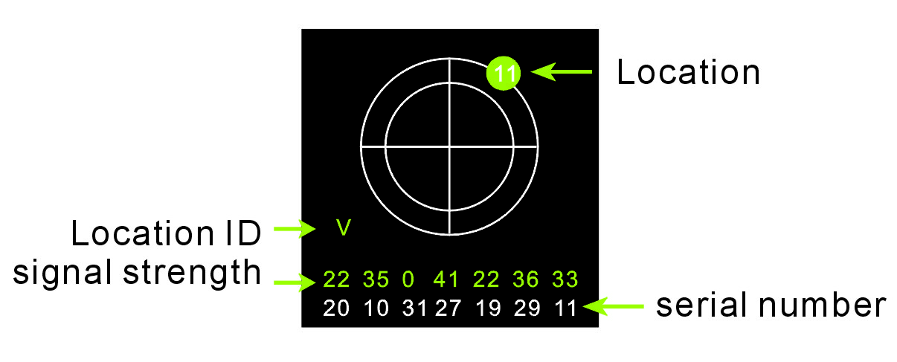
  - GPS Info: When power on, press the key to enter the function menu interface, then choose the GPS function (positioning status, latitude, longitude, altitude, speed, direction). The tracker will turn to the GPS function. It will correct and update the time. Shortcuts: Main interface buttons.
  - Others: The IMEI numbers, software version and battery status of the tracker.
- Mobile control and command setting
Notes: The following setup instruction can be applies to all mobile phone only before the guardian number
not be set. Such as the need to increase their privacy, please change the initial password and set guardians number.
Type | Command | Instruction | Function Remarks
Set class | Set guardian numbers | 11# mobile phone number  # password | Set guardian numbers, The initial password is 0000.
Set class | Set SOS numbers | 12# sos1# sos2 | Example: You can set 2 SOS numbers :  12#12345678910#12345678911
Set class | Password | 13#old password #  new password | Example: changed the password to 1234  13#0000#1234  Password: The acquiesced password is 0000.If forget new password after modifying, just connect computer with USB cable to check the password.txt file and find it out.
Set class | School quiet mode | 14#0 （OFF Default）  14#1 （Open） | From 8:00-11:30; 14:00-17:30, the tracker refuse all incoming calls except SOS numbers and the guardian numbers. LCD displaying to ensure with quiet.
Set class | GPS mode | 15#0 （OFF）  15#1 （Open Default） | The device default GPS + LBS dual positioning functions. When the positioning accuracy is not the case, turn off the GPS positioning mode can significantly extend the standby time! and LCD displaying.
Set class | Call Management | 16#0 （OFF）  16#1 （Open Default） | 16#0 Only authorized number to answer calls LCD displaying  16#1 Allow incoming calls to all numbers
Set class | factory settings | 0000 | Recover factory setting : 0000
Search for classes | Search Location（txt） | 21 | Search for GPS tracker’s current location information.  It can also be achieved by dialing the numbers to the GPS tracker: If dial the numbers and hang up within 5 seconds, the GPS tracker does not display incoming call, but sends a message to the caller. If over 5 seconds, the GPS tracker displays incoming call, then also send the current location to the caller automatically.
Search for classes | Search Location（Map） | 22 | Search for GPS tracker’s current location information and reply website link.
Search for classes | Set of query | 25 | Queries the current setting state of GPS Tracker
Search for classes | Balance of query | 36 | GPS tracker card balance inquiry  This’s for mainland China only.
Advanced Settings command | Track record set | 24#0 （Tracking off）  24#60 (Tracking open）  24## （Delete） | 24#60 (Default)（60 means 60 Mins）(from 1-99 mins).  Turn it on to set time (unit: minute); interval tracking record will be uploaded to the management platform. The LCD displays to show tracking record is on. The tracing data  Will be stored into the platform. The historical track can be viewed on the platform too. To save power,just turn off if platform connection no longer need.
Advanced Settings command | Internet access point settings | 32# Access Point  # User name # password | 32#cmnet##  Set the GPS tracker to access the network through cmnet access point. Usually the user name and password are not needed to fill and let it blank. For example: China Mobile: cmnet; China Unicom: uniwap; PCCW : pccw
Advanced Settings command | Management Platform setting | 34#0 （OFF）  34#1 （Open Default） | LCD display  to show the management platform open, the terminal connecting through the GPRS network, then the platform can send commands to the GPS tracking device.To save power,just turn off if platform connection no longer need.
Advanced Settings command | SMS forward settings | 35#0 （OFF Default）  35#1 （open） | To forward the received SMS to the guardian mobile phone. ( messages from the guardian excluded)  This’s available for guardian in mainland China only.
 | Phone monitory settings | 23# Number | 23# Ask for dialing back.  23#12345678910  Monitor number refers to the number which the tracker dialed back; It can be a mobile phone or non-mobile.
  - The above details for reference only, we reserve the rights to make amendment without prior notice.
  - All copyright are reserved.

